**25**

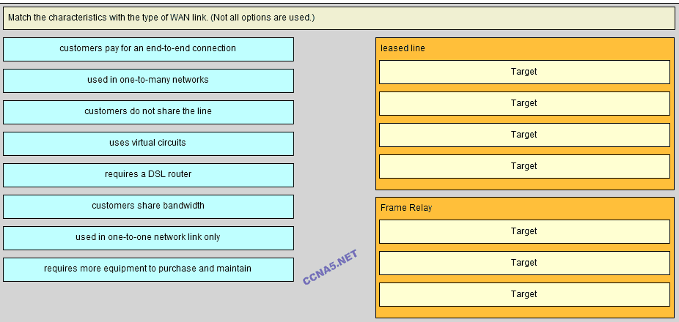

**Place the options in the following order:**   
**[+] customers pay for an end-to-end connection**   
**[+] customers do not share the line**   
**[+] requires more equipment to purchase and maintain**   
**[+] used in one-to-one network link only**

**[#] used in one-to-many networks**   
**[#] uses virtual circuits**   
**[#] customers share bandwidth**

**[+] Order does not matter within this group.**  
**[#] Order does not matter within this group.**